Experiment 8: Two-Layer Neural Network with Backpropagation

1. Aim
To implement a two-layer neural network with input, hidden and output layers using NumPy. To perform forward propagation using sigmoid activation functions, implement backpropagation manually using the chain rule, train the network using gradient descent, plot loss against epochs, visualize non-linear decision boundaries for XOR and two-moons datasets, and verify the calculated gradients using numerical gradient checking.

2. Formula(s)
1. Weighted Sum (Forward Propagation): Z1 = X × W1 + b1, Z2 = A1 × W2 + b2
2. Sigmoid Activation Function: σ(z) = 1 / (1 + e^(-z))
3. Hidden Layer Activation:A1 = σ(Z1)
4. Output Layer Activation:A2 = σ(Z2)
5. Binary Cross-Entropy Loss: L = -(1/N) × Σ [y × log(A2) + (1-y) × log(1-A2)]
6. Backpropagation
dZ2 = A2 - Y
dW2 = (A1.T × dZ2) / N
db2 = Σ(dZ2) / N
dZ1 = (dZ2 × W2.T) × A1 × (1-A1)
dW1 = (X.T × dZ1) /
db1 = Σ(dZ1) /
7. Gradient Descent Update Rule: W1 = W1 - α × dW1, b1 = b1 - α × db1, W2 = W2 - α × dW2, b2 = b2 - α × db2
8. Numerical Gradient Checking: Numerical Gradient =[L(W + ε) - L(W - ε)] / (2 × ε)

3. Overall Flow Diagram
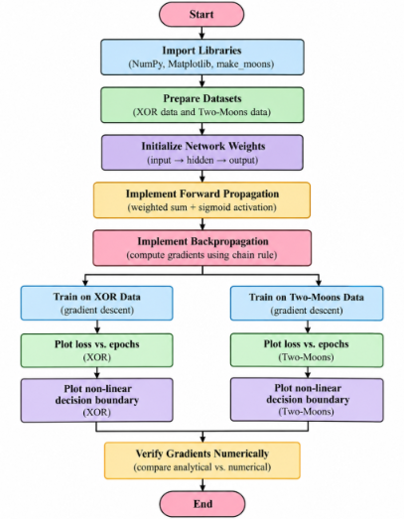
4. Code :
import numpy as np
import matplotlib.pyplot as plt
from sklearn.datasets import make_moons
from sklearn.preprocessing import StandardScaler
np.random.seed(42)
def sigmoid(z):
z = np.clip(z, -500, 500)
return 1 / (1 + np.exp(-z))
def initialize_weights(hidden_size, seed=42):
rng = np.random.default_rng(seed)
W1 = rng.normal(0, np.sqrt(1/2), (2, hidden_size))
b1 = np.zeros((1, hidden_size))
W2 = rng.normal(0, np.sqrt(1/hidden_size), (hidden_size, 1))
b2 = np.zeros((1, 1))
return W1, b1, W2, b2
def forward_propagation(X, W1, b1, W2, b2):
Z1 = np.dot(X, W1) + b1
A1 = sigmoid(Z1)
Z2 = np.dot(A1, W2) + b2
A2 = sigmoid(Z2)
return A1, A2
def calculate_loss(Y, A2):
epsilon = 1e-8
A2 = np.clip(A2, epsilon, 1-epsilon)
loss = -np.mean(
Y * np.log(A2) +
(1-Y) * np.log(1-A2)
)
return loss
def backward_propagation(X, Y, A1, A2, W2):
m = X.shape[0]
dZ2 = A2 - Y
dW2 = np.dot(A1.T, dZ2) / m
db2 = np.sum(dZ2, axis=0, keepdims=True) / m
dZ1 = np.dot(dZ2, W2.T) * A1 * (1-A1)
dW1 = np.dot(X.T, dZ1) / m
db1 = np.sum(dZ1, axis=0, keepdims=True) / m
return dW1, db1, dW2, db2
def train_network(X, Y, hidden_size=8,
epochs=5000, learning_rate=1.0,
seed=42):
W1, b1, W2, b2 = initialize_weights(
hidden_size, seed
)
losses = []
for epoch in range(epochs):
A1, A2 = forward_propagation(
X, W1, b1, W2, b2
)
loss = calculate_loss(Y, A2)
losses.append(loss)
dW1, db1, dW2, db2 = backward_propagation(
X, Y, A1, A2, W2
)
W1 -= learning_rate * dW1
b1 -= learning_rate * db1

W2 -= learning_rate * dW2
b2 -= learning_rate * db2
A1, A2 = forward_propagation(
X, W1, b1, W2, b2
)
predictions = (A2 >= 0.5).astype(int)
accuracy = np.mean(predictions == Y) * 100
return W1, b1, W2, b2, losses, accuracy
X_xor = np.array([
[0, 0],
[0, 1],
[1, 0],
[1, 1]
], dtype=float)

Y_xor = np.array([
[0],
[1],
[1],
[0]
], dtype=float)

W1, b1, W2, b2, xor_losses, xor_accuracy = train_network(
X_xor, Y_xor,
hidden_size=8,
epochs=5000,
learning_rate=1.0,
seed=42
)

print("XOR DATASET")
print("Final Loss:", round(xor_losses[-1], 4))
print("Accuracy:", round(xor_accuracy, 2), "%")

A1, A2 = forward_propagation(
X_xor, W1, b1, W2, b2
)

print("Actual Output:", Y_xor.ravel())
print("Predicted Output:", (A2 >= 0.5).astype(int).ravel())
X_moons, Y_moons = make_moons(
n_samples=300,
noise=0.20,
random_state=42
)
Y_moons = Y_moons.reshape(-1, 1)
scaler = StandardScaler()
X_moons = scaler.fit_transform(X_moons)
W1_m, b1_m, W2_m, b2_m, moon_losses, moon_accuracy = train_network(
X_moons, Y_moons,
hidden_size=12,
epochs=5000,
learning_rate=1.0,
seed=7
)
print("\nTWO-MOONS DATASET")
print("Final Loss:", round(moon_losses[-1], 4))
print("Accuracy:", round(moon_accuracy, 2), "%")
plt.figure(figsize=(9, 5))
plt.plot(xor_losses, label="XOR Dataset")
plt.plot(moon_losses, label="Two-Moons Dataset")
plt.xlabel("Epochs")
plt.ylabel("Binary Cross-Entropy Loss")
plt.title("Loss vs Epochs")
plt.legend()
plt.grid()
plt.show(
def plot_decision_boundary(X, Y, W1, b1, W2, b2, title):

x_min, x_max = X[:, 0].min()-0.5, X[:, 0].max()+0.5
y_min, y_max = X[:, 1].min()-0.5, X[:, 1].max()+0.5

xx, yy = np.meshgrid(
np.linspace(x_min, x_max, 200),
np.linspace(y_min, y_max, 200)
)

grid = np.c_[xx.ravel(), yy.ravel()]

_, predictions = forward_propagation(
grid, W1, b1, W2, b2
)

predictions = predictions.reshape(xx.shape)

plt.contourf(
xx, yy, predictions,
levels=[0, 0.5, 1],
alpha=0.3
)

plt.scatter(
X[:, 0], X[:, 1],
c=Y.ravel(),
edgecolors='black'
)

plt.xlabel("Feature 1")
plt.ylabel("Feature 2")
plt.title(title)
plt.show()

plot_decision_boundary(
X_xor, Y_xor, W1, b1, W2, b2,
"XOR Decision Boundary"
)
plot_decision_boundary(
X_moons, Y_moons, W1_m, b1_m, W2_m, b2_m,
"Two-Moons Decision Boundary"
)

W1, b1, W2, b2 = initialize_weights(8, seed=42)

A1, A2 = forward_propagation(
X_xor, W1, b1, W2, b2
)

dW1, db1, dW2, db2 = backward_propagation(
X_xor, Y_xor, A1, A2, W2
)

epsilon = 1e-5

W1_plus = W1.copy()
W1_minus = W1.copy()

W1_plus[0, 0] += epsilon
W1_minus[0, 0] -= epsilon

_, A2_plus = forward_propagation(
X_xor, W1_plus, b1, W2, b2
)

_, A2_minus = forward_propagation(
X_xor, W1_minus, b1, W2, b2
)

loss_plus = calculate_loss(Y_xor, A2_plus)
loss_minus = calculate_loss(Y_xor, A2_minus)

numerical_gradient = (
loss_plus - loss_minus
) / (2 * epsilon)

analytical_gradient = dW1[0, 0]

print("\nGRADIENT VERIFICATION")

print("Numerical Gradient:",
numerical_gradient)

print("Analytical Gradient:",
analytical_gradient)

print("Difference:",
abs(numerical_gradient - analytical_gradient))

if abs(numerical_gradient - analytical_gradient) < 1e-5:
print("Gradient Check Passed!")
else:
print("Gradient Check Failed!")
5. Output
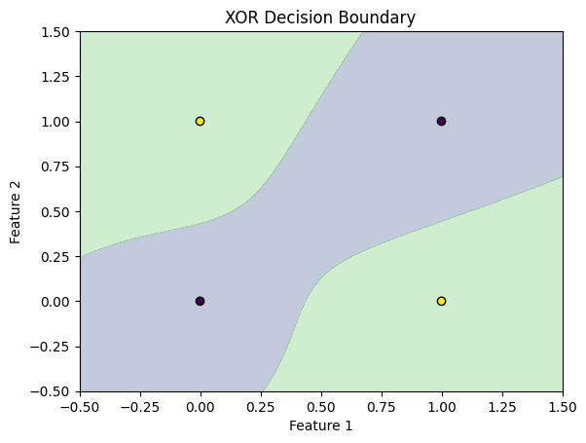
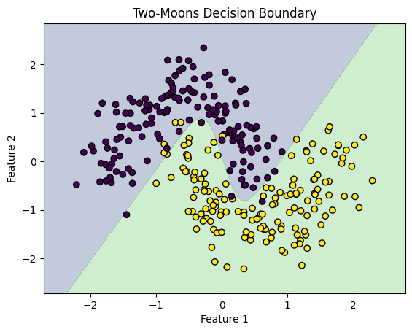
GRADIENT VERIFICATION
Numerical Gradient: 0.00121978
Analytical Gradient: 0.0012197844907511318
Difference: 6.703765147164642e-13
Gradient Check Passed!

6. Result
A two-layer neural network was successfully implemented using NumPy. Forward propagation and backpropagation were performed manually using sigmoid activation and the chain rule. The network successfully learned the XOR and two-moons patterns. Loss graphs and non-linear decision boundaries were plotted, and numerical gradient checking verified the correctness of backpropagation.

